|  |  |  |  |
| --- | --- | --- | --- |
| How can we help your business? We offer free and effective marketing through a variety of methods including automated phone calls, a website, live events, and social media like Twitter. With the families of 2000 students and over 180 staff members, we can market your business to thousands of potential customers and future employees. | |  | | --- | | 2,000 students ____ Multiplied by an average household of at least 4 people ____ More than 180 staff members ____ Multiple methods of marketing ____ Student volunteers for your business and events | | Poinciana High School 2300 S Poinciana Blvd  Kissimmee, FL 34758  407-870-4860  pnhs.osceolaschools.net  #ReptheP | |

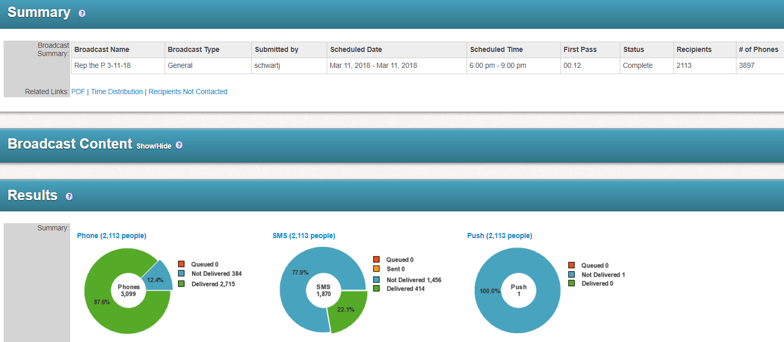

What can the power of positive messaging do for your business?

